Computer Language Coding Concepts

Clause in a Diagram
The principle of clauses is explained in the article Clause. This article demonstrates their expression in a diagram.

A clause is a procedure defined within a procedure.

An active clause is shown in a diagram as a diamond placed inside a procedure symbol:



An inactive clause is shown in a diagram as a square inside a procedure symbol.



A clause can just as well be placed inside a diamond, instead of a square:

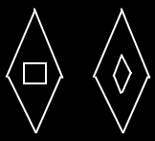

A clause will never redirect its definition to another procedure, because the thing that makes a clause a clause, is that it is a procedure symbol within a procedure, that doesn’t redirect to another procedure.

See also: Clause

Author & Copyright: Jan-Joost van Zon Date: May 25, 2008 – May 25, 2008 Location: Oosterhout, The Netherlands Status: Finished

